Methods
Study design
This study was designed as a retrospective observational study carried out at the medical faculty of Ulm (Baden-Württemberg, Germany) between October 2022 and July 2023.
Medical students at Ulm university are enrolled in a lecture and a consecutive seminar on clinical pharmacology. Each extends over one semester and concludes with a written exam. As part of the regular curriculum, students are assigned to one of two groups and will be enrolled in the lecture either in the seventh or in the eighth semester, and in the seminar in the subsequent semester.
Examinees of two seminar exams (seminar 2022/23, and seminar 2023), and of two lecture exams (lecture 2022, lecture 2022/23), in total 632, were invited to participate in the study. The number of individual students was lower, since many examinees of the lecture exams for 2022 and 2022/23 did later participate in the seminar exams of 2022/23 and 2023 respectively.
The exams were single best-answer tests consisting of 40 (lecture) or 30 (seminar) test items, each with five options. Each correct item yielded one point. Passing both exams as well as attending the seminar are mandatory part of the curriculum, while lecture attendance is optional.
At the beginning of the lectures and of the seminars, students were made aware of the option to use Anki flash cards for studying, which were available for download on the course material website, along with a brief manual (explaining installation of the most up-to-date Anki version and importing, creating, and editing cards), as well as an FAQ.
Anki cards creation and structure
Anki is an open-source flashcard software available for most desktop and mobile platforms. Anki allows users to study material following a spaced repetition algorithm, in which the interval until next review of a card is determined by the learner’s self-rated confidence of correct recall. Cards in which recall is rated as difficult are scheduled for earlier repetition, and cards which were more easily remembered reoccur after a longer interval. Content for Anki can be downloaded from a free and user-generated online repository or created by end-users themselves.
Although no statistics are available on the popularity of Anki among German medical students, the platform is widely used in English-language medical education: 50.3% of students at two US medical schools in Georgia and Alabama reported preparing for the Step 2 Clinical Knowledge exam using Anki cards.(https://pmc.ncbi.nlm.nih.gov/articles/PMC12228608/#:~:text=to%20assess%20their%20study%20resource,reported%20Step%202%20CK%20scores, evtl. Lieeber in Intro oder Conclusion)
Anki cards for 226 drugs had been created by institute staff and were based on the 2021 version of the IMPP Arzneistoffliste (IMPP, 2021), which contains 307 pharmacological agents in total. The Arzneistoffliste defines key drugs and serves as an official guideline for the pharmacology-related items of the centralized written German medical licensing examinations. Drugs included in the Arzneistoffliste but not covered in the clinical pharmacology curriculum at Ulm University were not converted into Anki cards.
Cards were organized in distinct decks according to medical fields, and further divided into two decks for each field:
- A basis deck showing the drug name on the front, and on the back either the effect, the mechanism of action, indications, contraindications, side effects, interactions, or special features such as notable
- A comprehensive knowledge deck, showing the drug name on the front and extended drug information on the back.
Information on the reverse side was mostly presented as bullet lists or single terms, and occasionally short texts or diagrams when appropriate. Cards were tagged for efficient filtering in Anki, including a tag for those cards considered relevant for the exam concluding the lecture and the seminar.
Other studying materials made available to students were lecture and seminar slides, comprehensive electronic scripts accompanying the lecture, example questions, case tasks and exercises as part of our e-learning repository, and textbook recommendations. Students were free to download external Anki decks or create their own.
Questionnaire
Immediately after both the lecture and seminar exam, students were handed survey questionnaires comprising 22 items.
Students were asked which learning materials they employed and considered particularly useful for exam preparation, including the institute-supplied Anki cards. Students were also asked whether they had used Anki cards in general and were asked to report on their Anki usage in detail when answering positively. These detailed questions included whether students considered the Anki cards useful in general, to what extent they used them, for what purposes and in which situations, and on what kind of device. Students who reported not having used the institute-supplied cards were asked to indicate their reasons.
Participants were asked to rate their general academic performance on a five-point ordinal scale. Since exam scores in other subjects were not available to us, self-assessment of academic performance served as a proxy. Students were finally asked for basic demographic information.
Students explicitly consented to data processing.
Students generate a pseudonymous code as part of routine exam procedure to write on their response sheet before handing it in. For this study, they were invited to voluntarily provide their code on the survey questionnaire as well, allowing us to pseudonymously match survey questionnaires with exam results.
Questionnaire design and initial data preparation was done using EvaSys software (evasys GmbH, Konrad-Zuse-Allee 13, 21337 Lüneburg, Germany).
Data evaluation and statistics
For descriptive statistics and for comparing exam difficulty, exam scores were transformed into percentages of maximum scores. For all other inference statistics, exam scores were z-standardized within each cohort before pooling to account for differing exam difficulty.
Differences in categorical variables were assessed using chi-square tests, and ordinal variables were compared between cohorts using Wilcoxon rank-sum tests.
To investigate whether exam performance differed between Anki users and non-users, we first fitted an unadjusted linear regression model with exam score as the dependent variable and Anki use as the independent variable. We then fitted an adjusted model including self-rated academic performance as a covariate to account for potential confounding by general academic ability. For the unadjusted regression we excluded participants who did not self-rate their academic performance to ensure that both the adjusted and the unadjusted regression were done on the same data set.
Statistical significance was set at p < 0.05.
All correlation analyses used Spearman’s ρ.
Statistical analysis was performed in R version 4.4.1 (R Core Team, 2024), using the package ggplot2 (Wickham, 2016) for figures.
Results
Descriptive statistics
Out of 716 exam participants, 632 (88.3%) returned the survey questionnaire, consented to data processing, and provided their pseudonymous code for matching survey data with exam scores (Table 1). Across all exams, participants correctly answered 76.1% of items, with significantly higher score percentages in lecture exams (77.4%) as compared to seminar exams (74.8%), t(601) = 2.689, p < .001, 95% CI [0.70, 4.52].
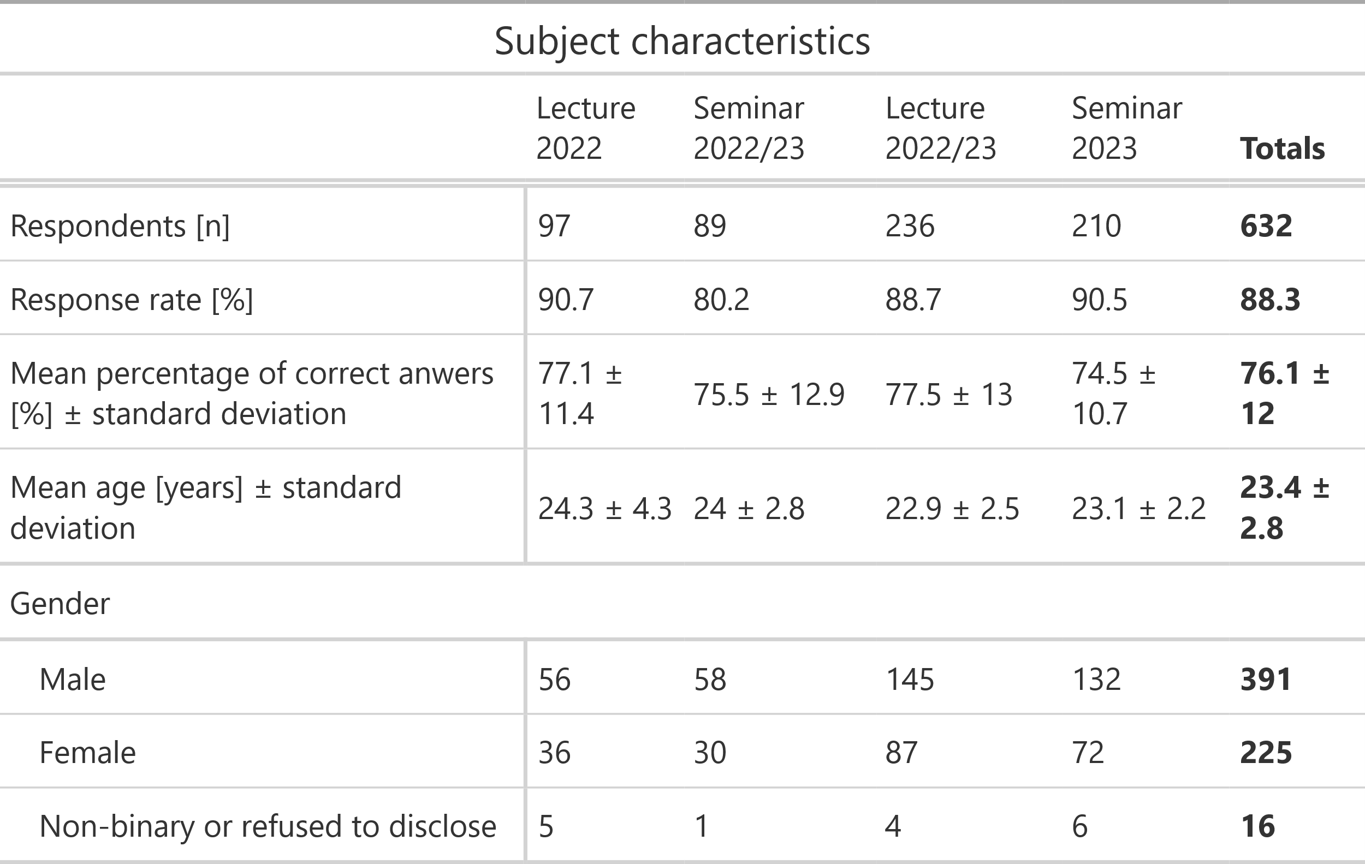
Table 1. Demographic and response characteristics of the study population.
The most frequently used study materials were digital scripts (Figure 1), followed by physical scripts and institute-supplied Anki cards. Anki usage differed significantly between preparation for lecture exams (45.0%) vs. seminar exams (21.4%), χ²(1, N = 632) = 38.266, p < .001.
Students considered scripts (both digital and physical) most useful for exam preparation, followed by lecture and seminar videos (Figure 2). Among students who reported having used Anki for exam preparation (29.9%), 65.4% counted Anki cards among those studying materials considered “particularly helpful” in exam preparation (Figure 3), with no significant differences between cohorts, χ²(3, N = 214) = 2.636, p = 0.4512, and no significant differences between lecture and seminar exam, χ²(1, N = 214) = 0.55309, p = 0.4571. Among students who reported having used institute-provided Anki-cards in general (32.4%), 81.9% considered them as helpful in general (Figure 4), with no significant cohort differences either, χ²(3, N = 232) = 3.751, p = 0.2896, and no significant differences between seminar and lecture exams, χ²(1, N = 232) = 0.38739, p = 0.5337.
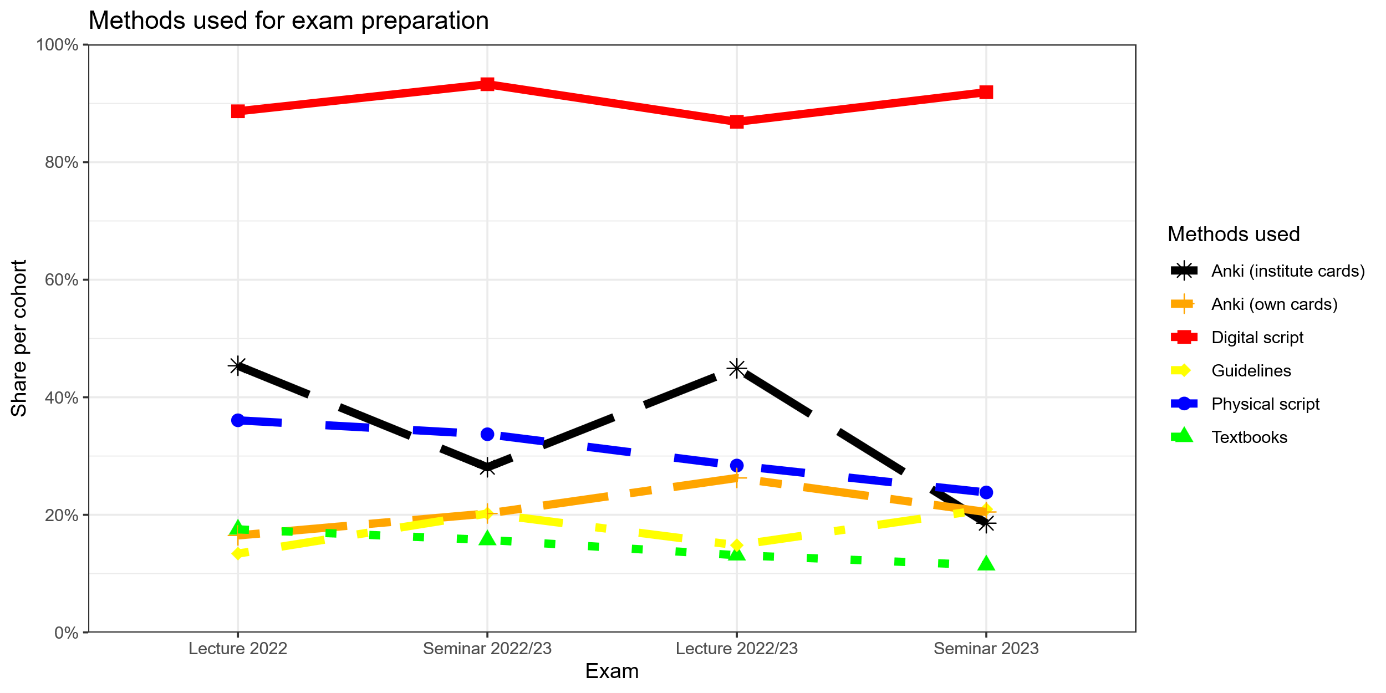
Figure 1. Methods used for exam preparation by cohort. Multiple answers allowed.
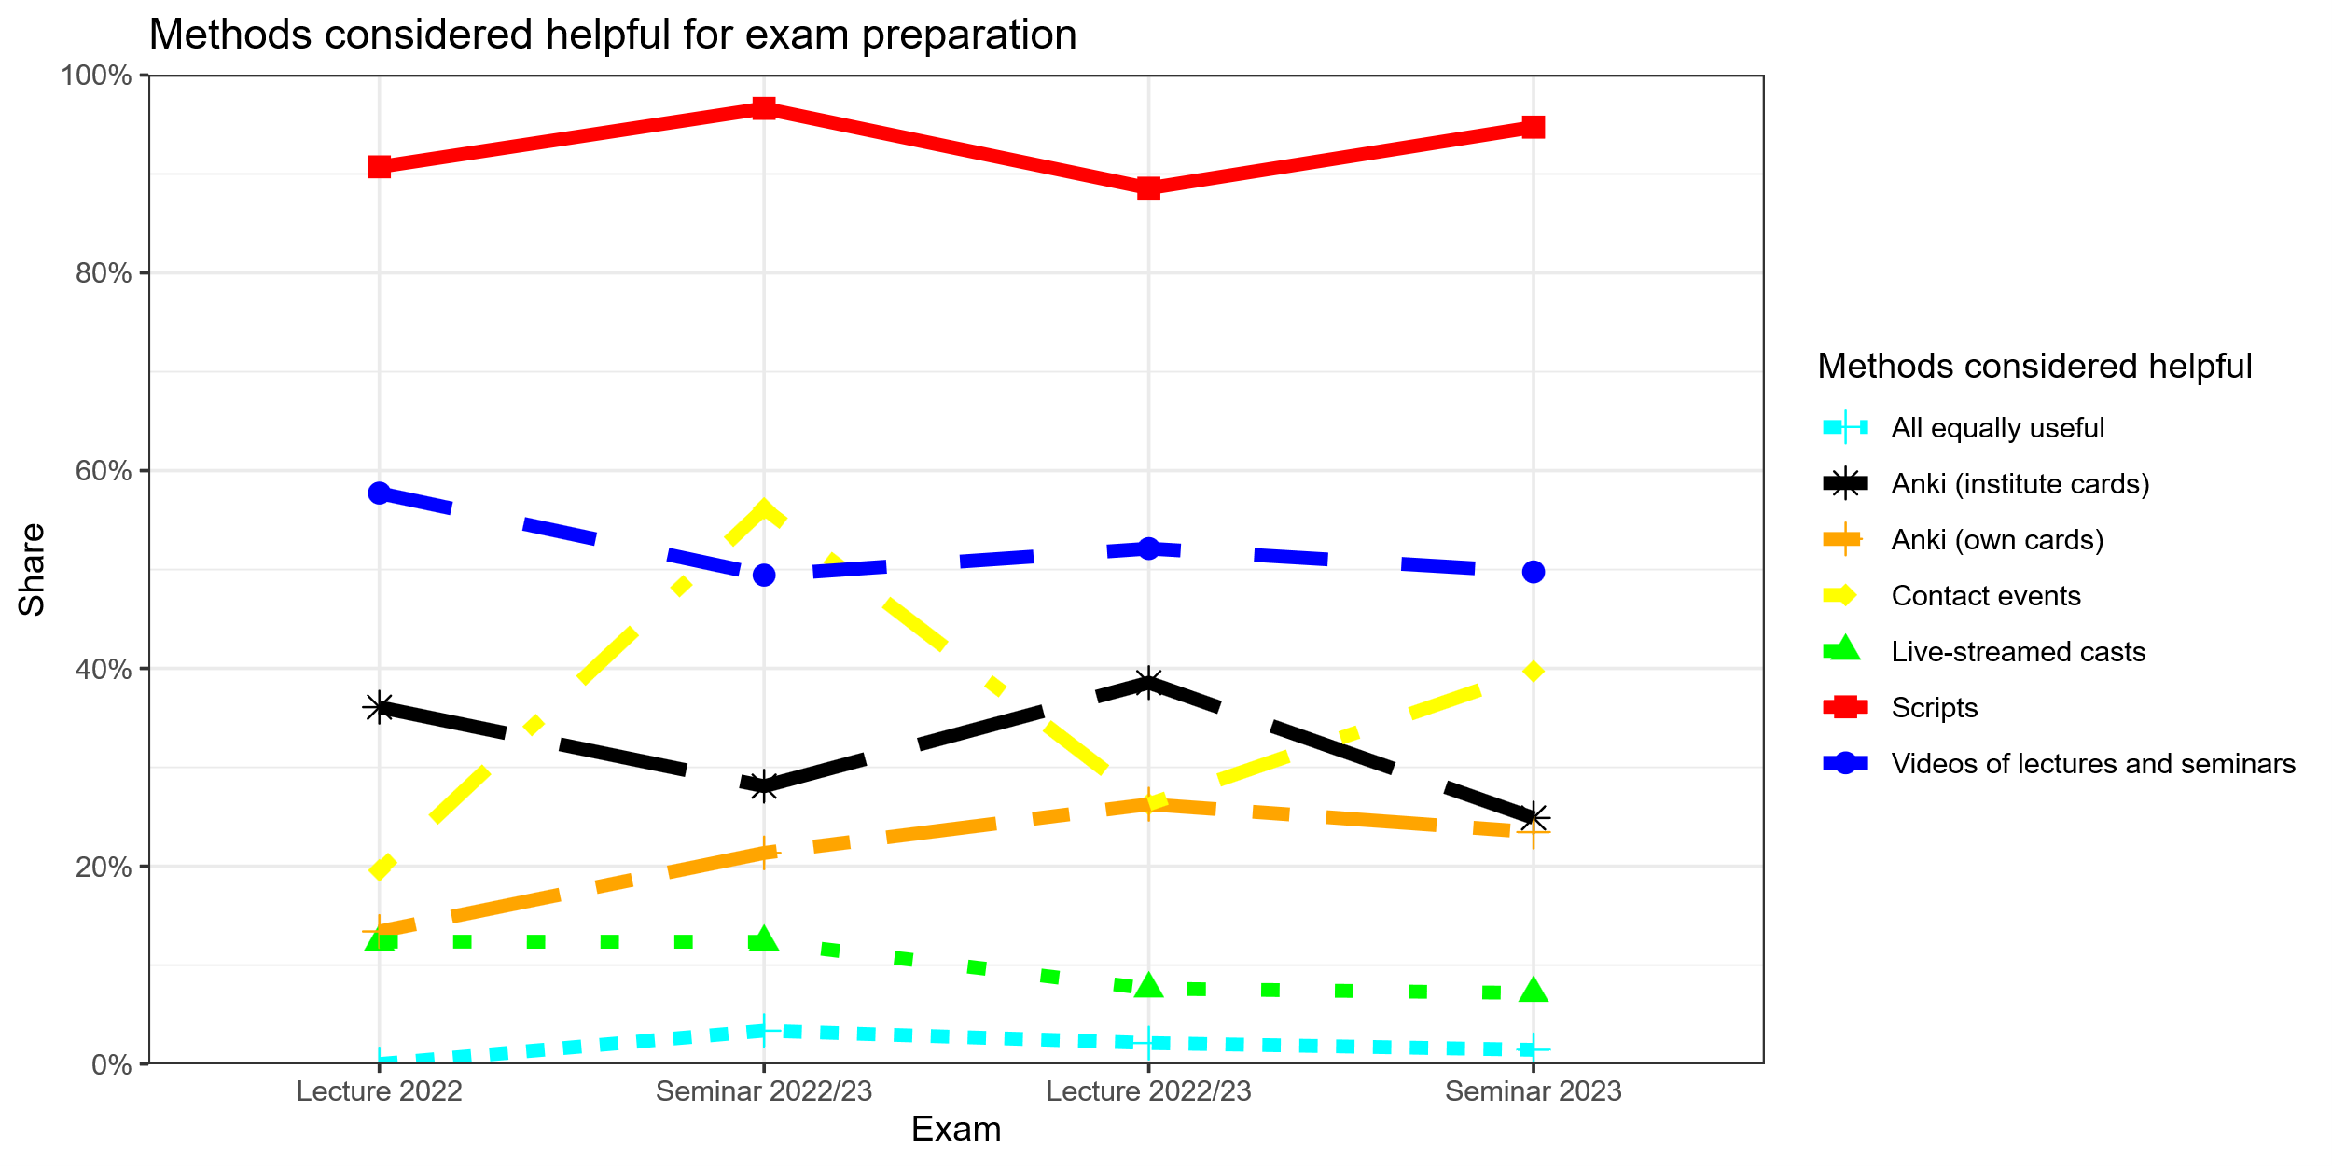
Figure 2. Methods considered particularly helpful for exam preparation among all students by cohort. Multiple answers allowed.
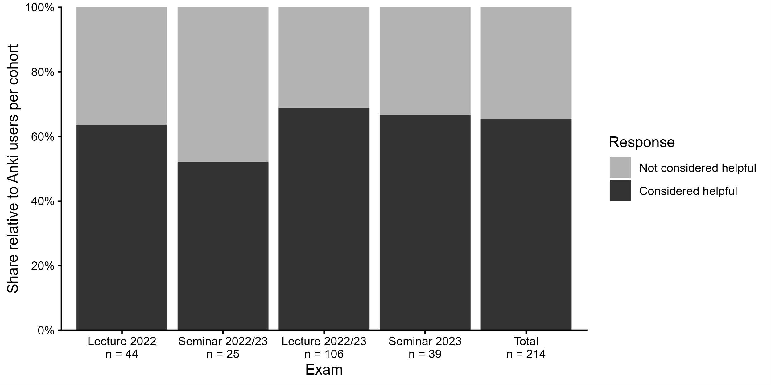
Figure 3. Share of students who considered Anki as “particularly helpful” in exam preparation, relative to all students who prepared for the exam using Anki institute cards.
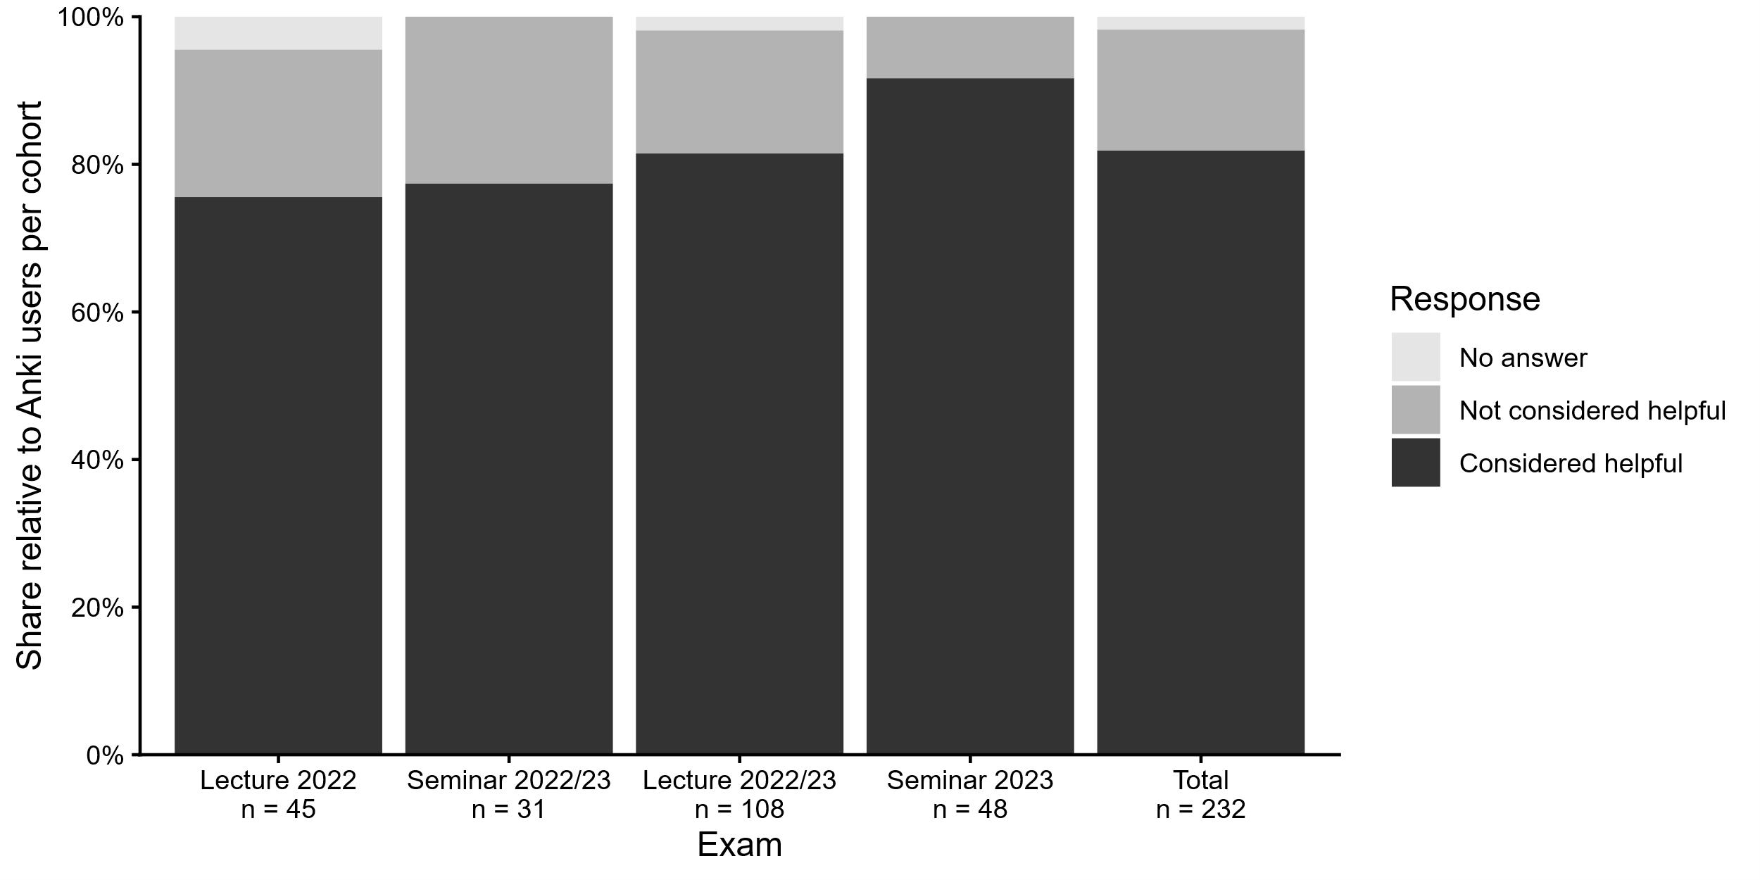
Figure 4. Share of students who considered Anki institute cards as generally helpful, relative to all students who declared having used the cards in general.
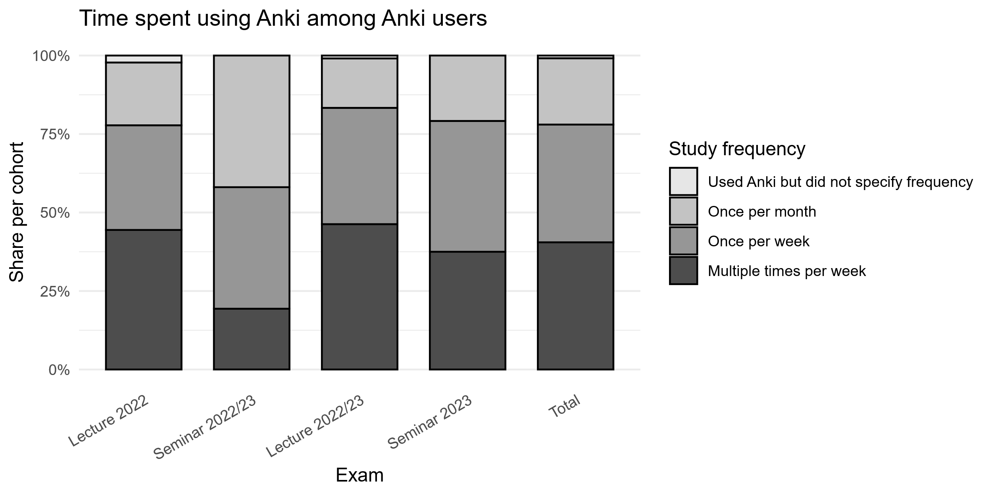
Figure 5. Frequency of Anki usage among students who reported having used Anki cards in general.
Among students who had used Anki in general (Figure 5), most had used Anki multiple times per week (40.5%) or once per week (37.5%). Among non-users (Figure 6), most indicated insufficient time as a reason (49.1%), or considered the available material as already sufficient for exam preparation (37.3%).
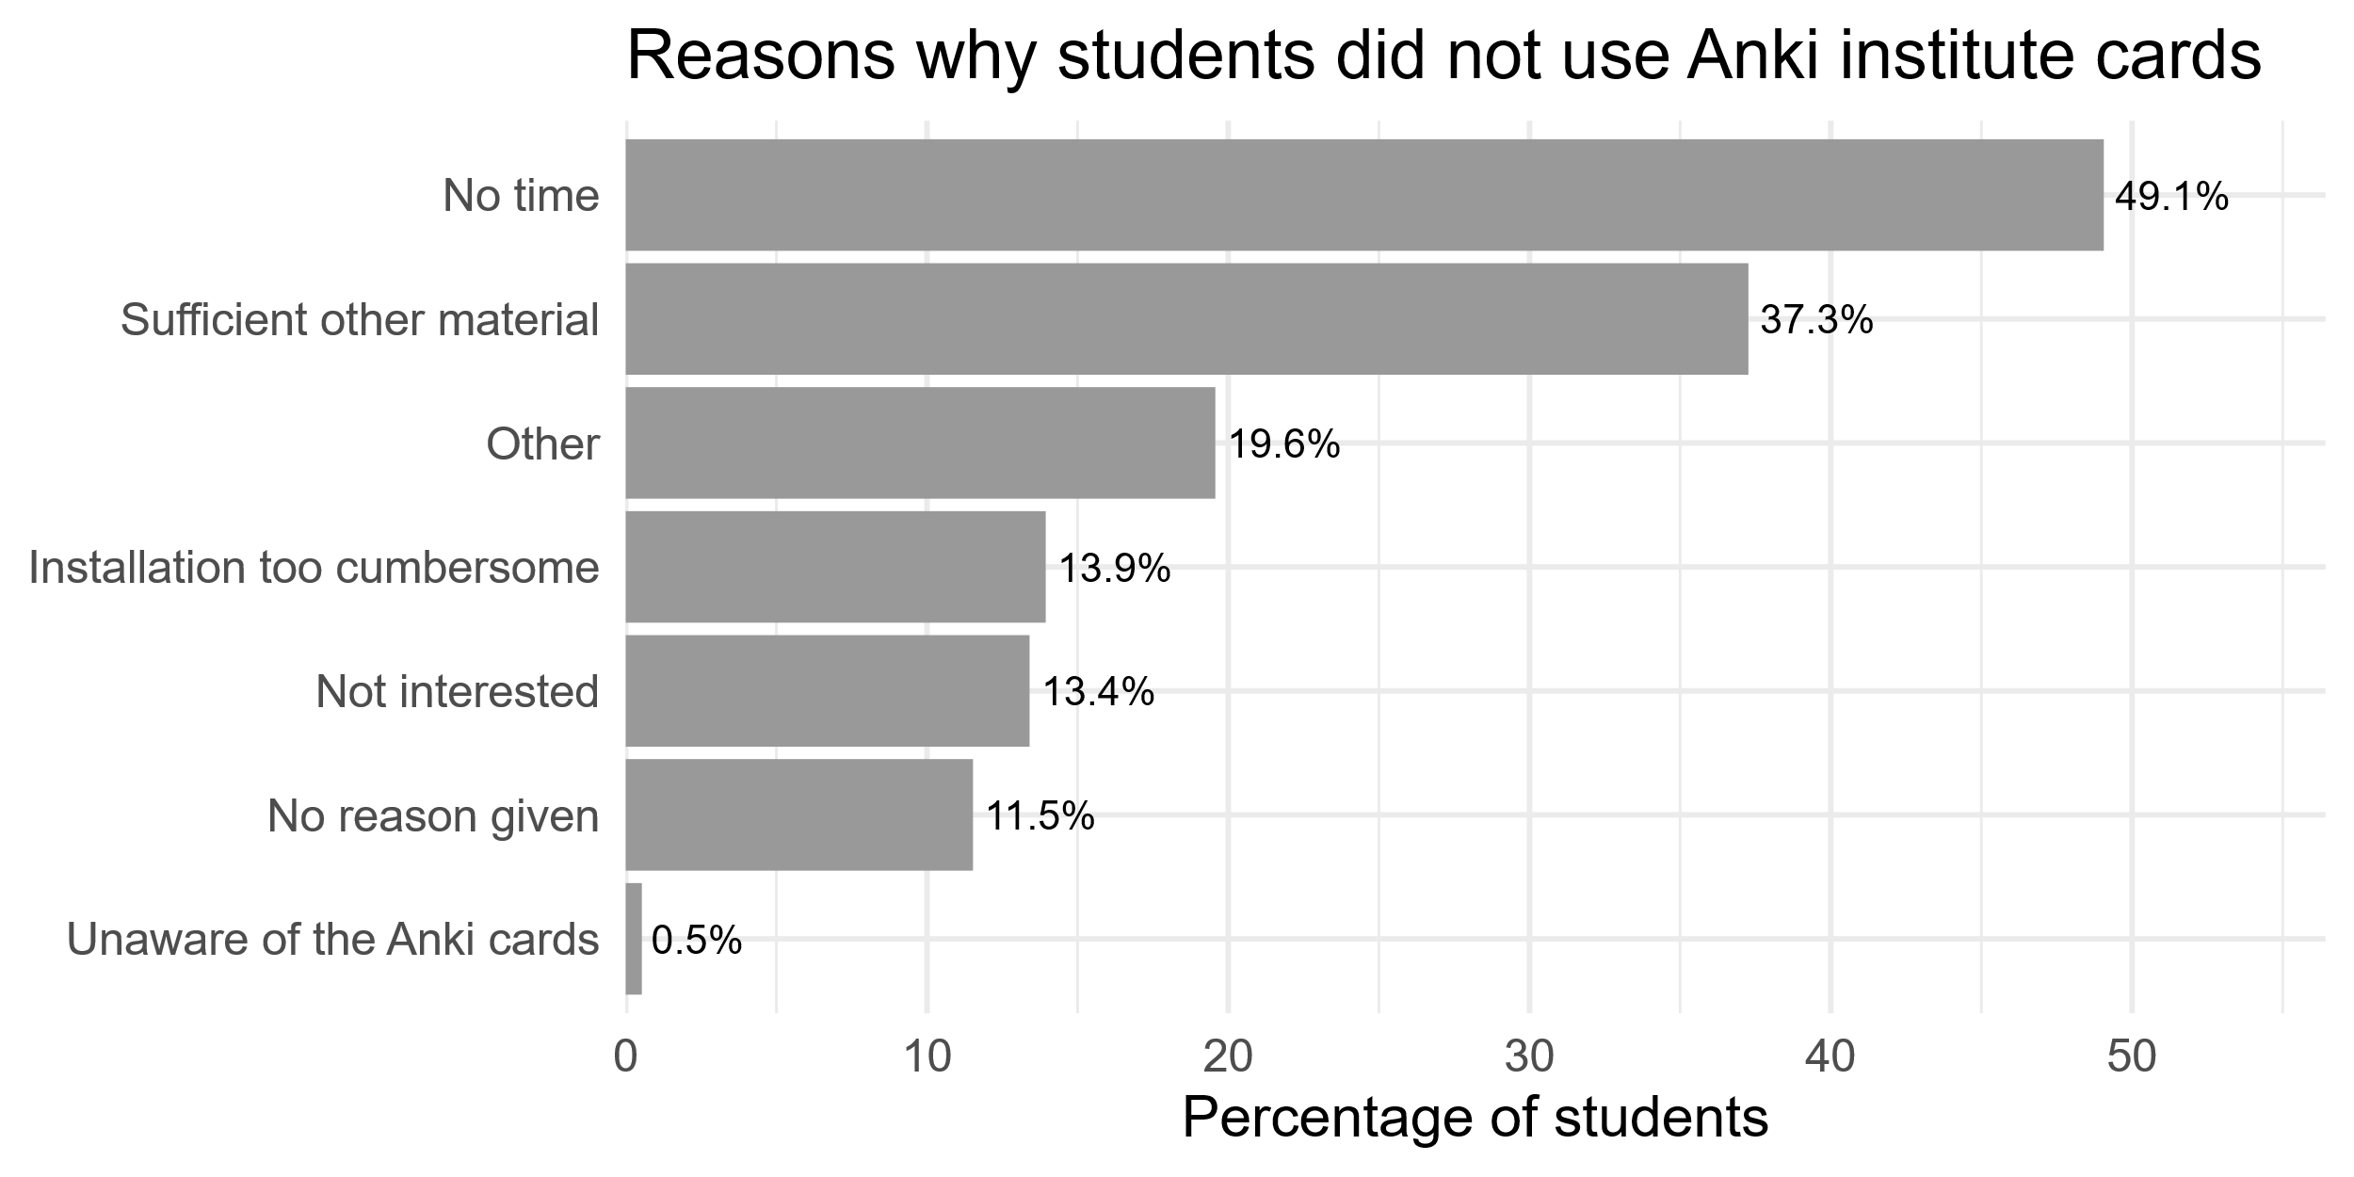
Figure 6. Reasons for not using Anki.
Participants studying with institute-provided Anki cards had similar or lower exam scores compared to non-users (Figure 7). After z-standardizing exam scores within each cohort and pooling across all cohorts, Anki users performed significantly lower than non-users by 0.19 standard deviations on average (β = –0.19, SE = 0.08, p = .018).
Self-rated general academic performance (“how would you assess your overall academic performance compared to other students in your semester?”; Figure 8) was positively correlated with z-standardized exam scores (ρ = .35, p < .001), and negatively correlated (Figure 9) with Anki usage (ρ = –.09, p = .014).
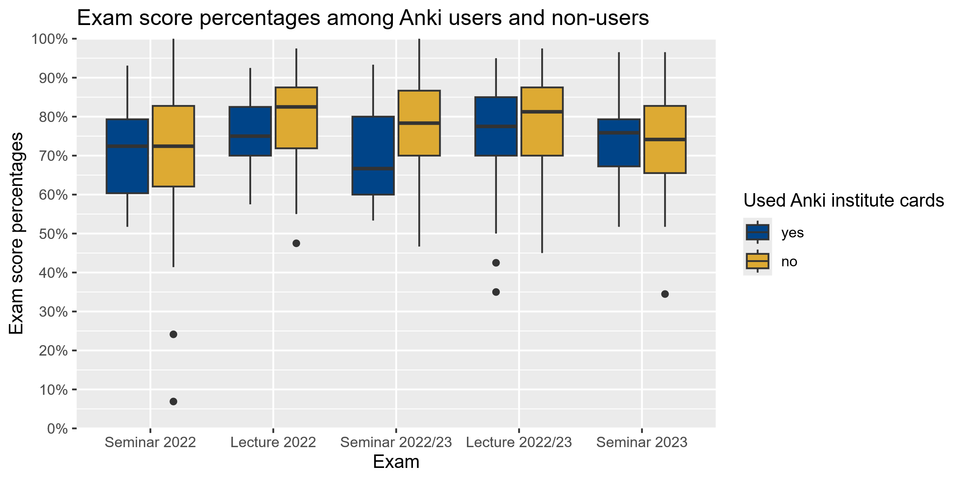
Figure 7. Anki usage and exam scores by cohort.

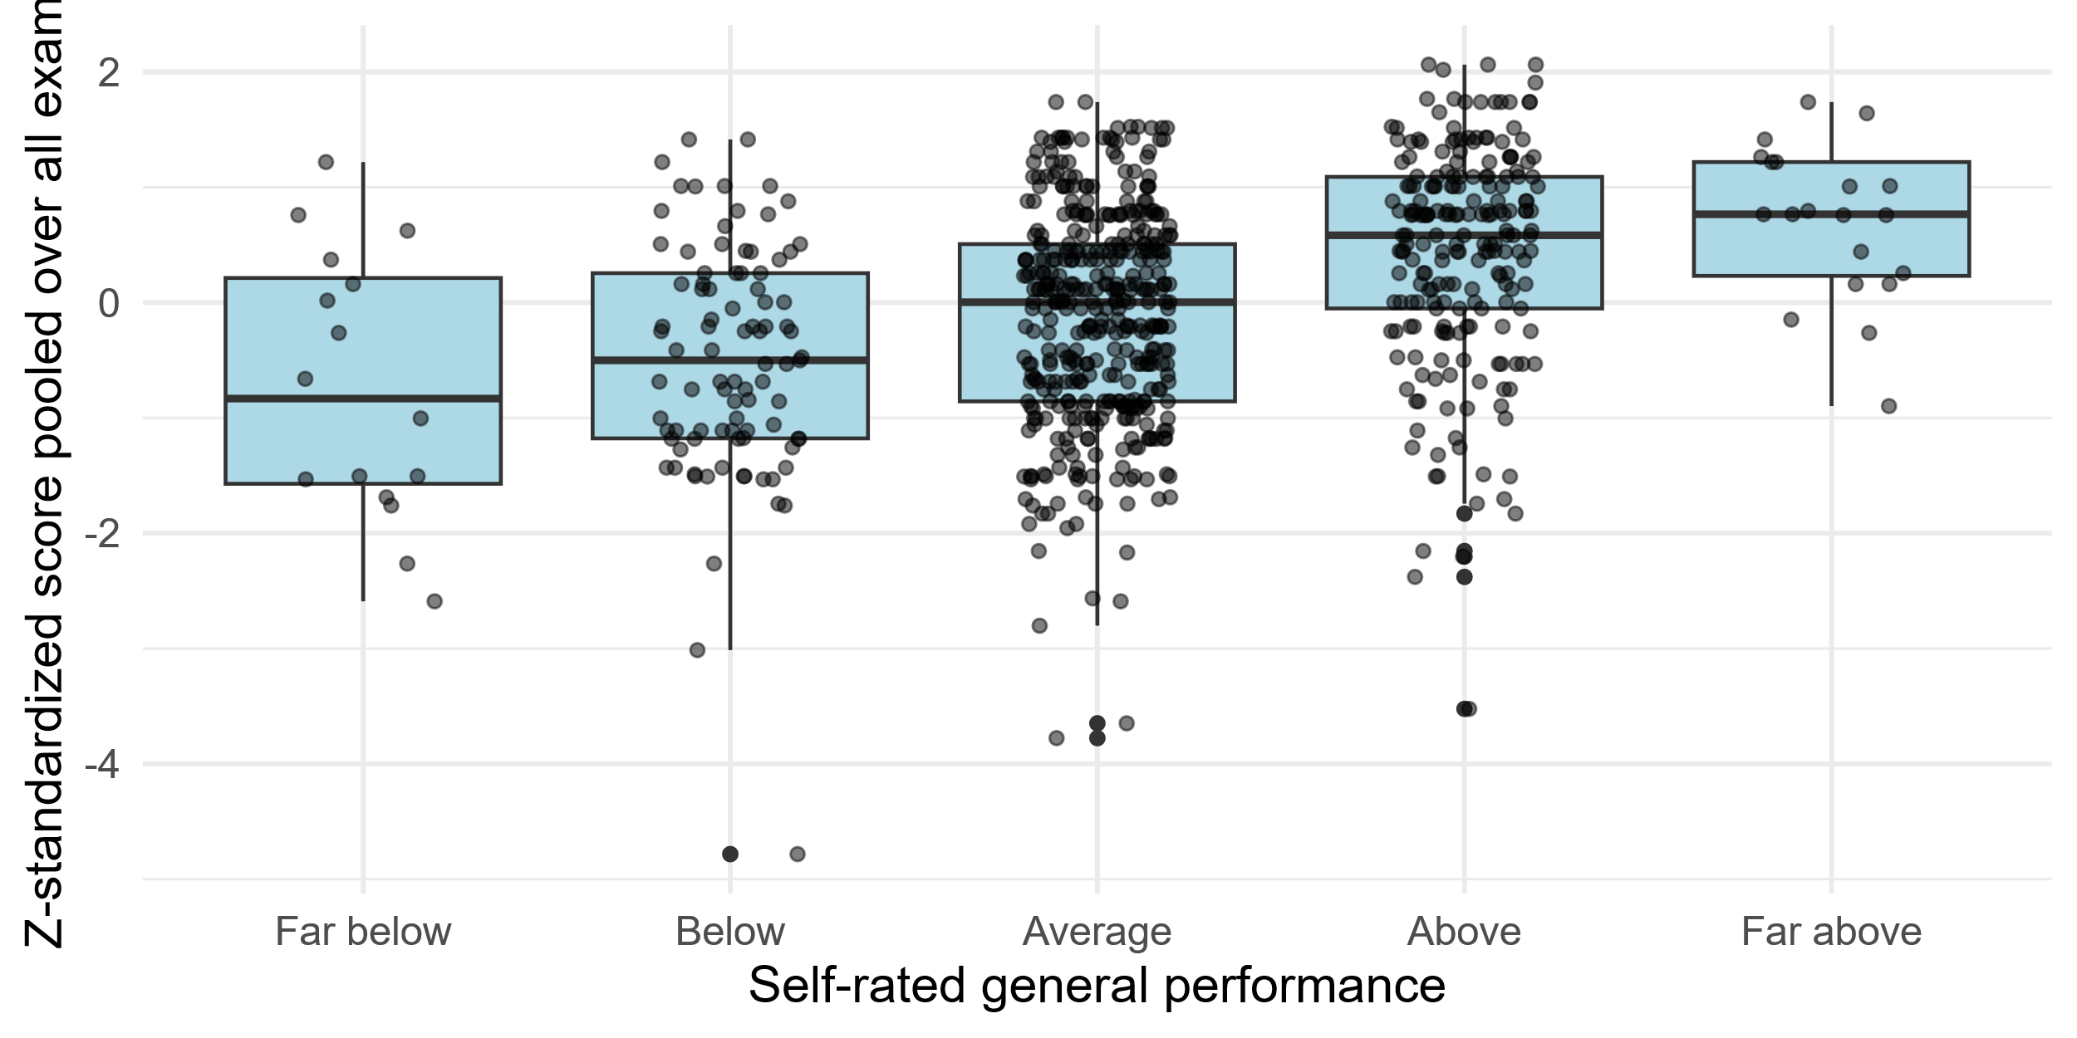
Figure 8. Relationship between self-rated academic performance and standardized exam scores.
When adjusting the regression analysis between Anki usage and exam scores for self-rated academic performance, the negative association between Anki usage and exam scores was no longer statistically significant (β = –0.13, SE = 0.08, p = .095). An F-test comparing the adjusted with the unadjusted model confirmed that including self-rated performance significantly improved model fit (ΔR² = .126, F(1, 746) = 89.35, p < .001). The adjusted model explained 11.3% of the variance in exam scores, compared to less than 1% in the unadjusted model.

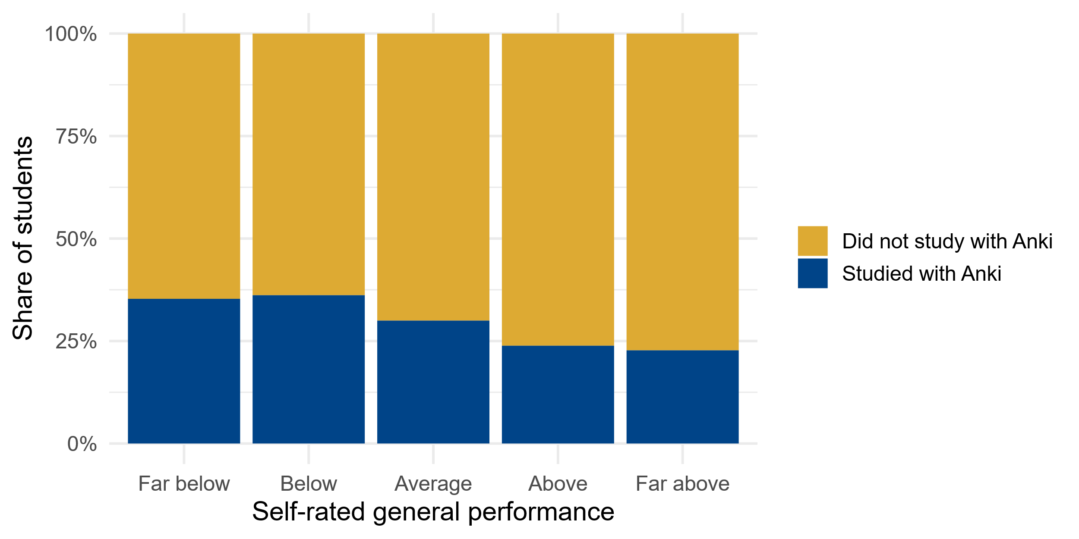
Figure 9. Self-rated performance and Anki usage.
Erwähnen, dass kein anderes Lernmittel sign. Prädiktor war (evtl. als Tabelle)
Fehlt noch im Results-Teil:
- Zeitaufwand der Kartenerstellung
- Keines der anderen Lernmittel (eigene Ankikarten, digitale und physische Skripte, Leitlinien, Lehrbücher) war signifikanter Prädiktor des Examscores. Sollte ich das trotzdem erwähnen, dass der Zusammenhang untersucht wurde, aber nichts gefunden wurde? Interessanterweise waren die meisten Lernmittel negativ mit dem Score korreliert, aber eben wie gesagt nicht signifikant.
Conclusions
- Anki cards were mainly used for studying for lecture, not seminar exam, perhaps since seminar exams are known to have a stronger focus on case miniatures
- Students performed significantly worse when studying with Anki, but this effect was not significant anymore when controlling for general academic performance. Students with lower academic performance seem to have opted for Anki as studying aid, perhaps hoping to compensate with Anki cards for a comparatively lower academic ability as compared to students with high self-rated performance.
- No causality can be inferred since no randomization was done, observational study only. However, in reality students self-select their studying material as well, and a randomized study would have missed self-selection of lower-performing students for Anki.
- Cost-benefit ratio dubious
- Among participants who declared a binary gender, the proportion of women was 62.1%. Which is close to the German average of female medical students in 2022 at 64.4% (Statistisches Bundesamt, 2025) muss noch umschreiben
References
Statistisches Bundesamt (Destatis). (2025). Studierende insgesamt und Studierende Deutsche im Studienfach Medizin (Allgemein-Medizin) nach Geschlecht [Data set]. GENESIS-Online. https://www-genesis.destatis.de
- Anzahl Lernmittel mit Noten, Anki-Gebrauch, Selbsteinschätzung
- Zusammenfassen, wenn keine sign. Unterschiede zwischen Kohorten
- Arlina (Mauder, Frank, Dopler, Susanne Hafner aktualisierten die Karten). Arthur fragen.
- Gruppe 1 rausnehmen und schauen was passiert
- Korrelation Lernmaterial mit Note je nach Kohorte
- Alter und Geschlecht
Weitere Results:
Kein sign. Unterschied in Anki-Nutzung zur Püfungsvorbereitung zwischen den beiden Seminars
Kein sign. Unterschied in Anki-Nutzung zur Püfungsvorbereitung zwischen den beiden Lectures
Falls used_anki_institute_general: Lerner auch signifikant schlechter in der Klausur, Signifikanz wird geringer wenn adjusted für self assessed performance, aber auch nach Korrektur immer noch signifikant.

